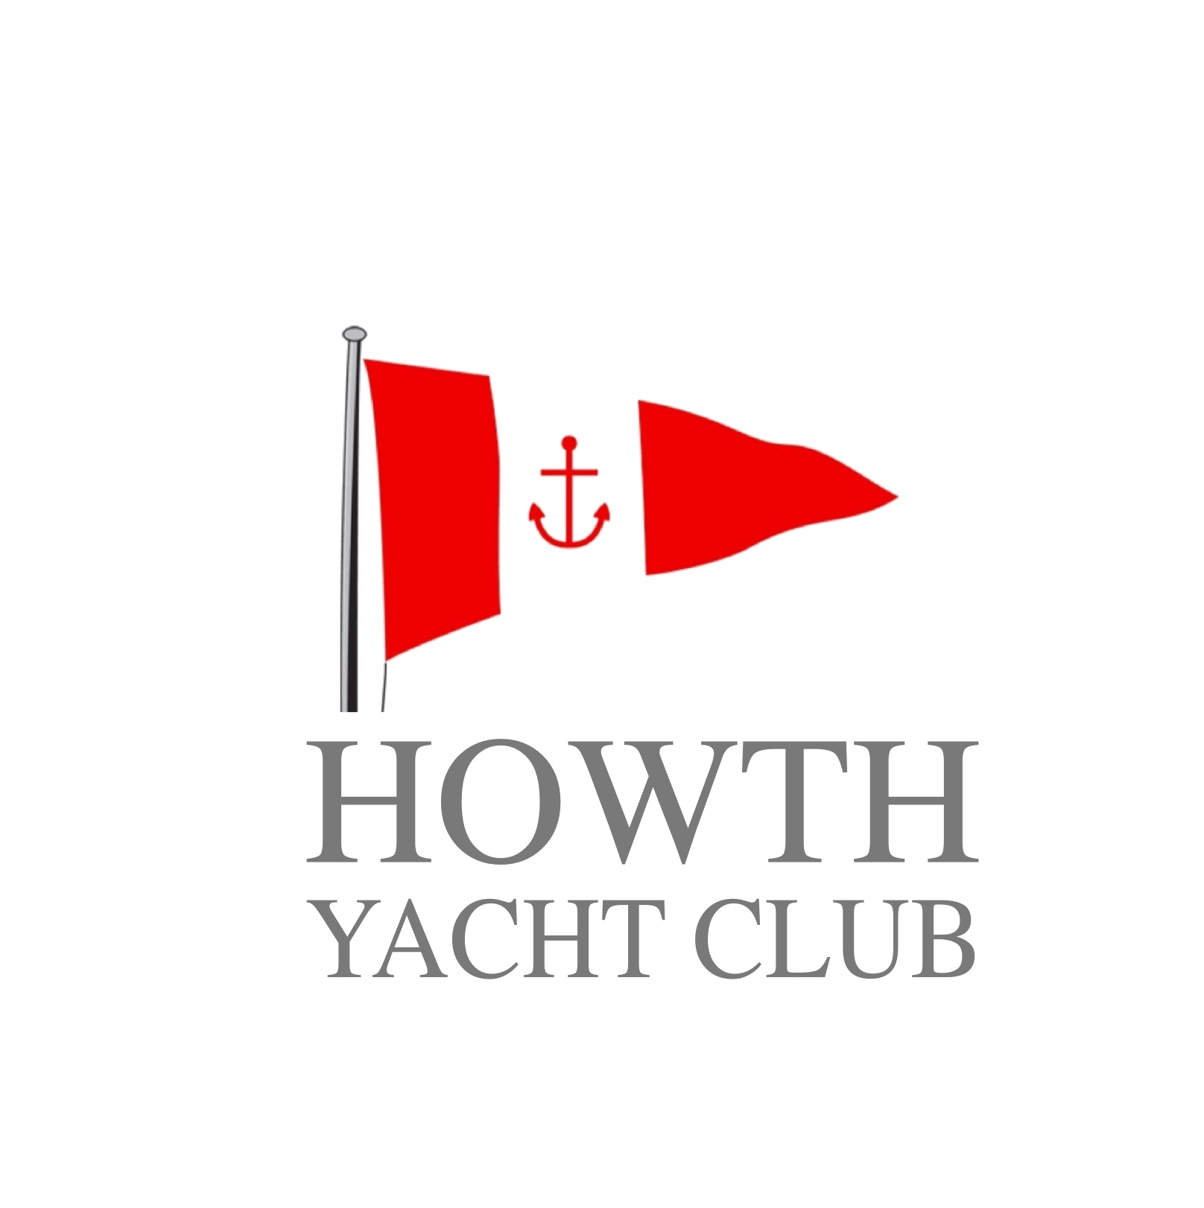 | HOWTH YACHT CLUB  Double Handed Race  2021  Organised by Howth Yacht Club CLG.  Saturday 17th July

Notice of Race

- ORGANISING AUTHORITY

  - The Organising Authority (OA) is Howth Yacht Club CLG.,
  - All enquiries should be addressed to the Honorary Sailing Secretary, Howth Yacht Club, Harbour Road, Howth, Co. Dublin, D13V6E3. Phone: 01 832 2141, Email: office@hyc.ie, Web site: www.hyc.ie

- RULES AND ELIGIBILITY

  - Races will be sailed under the Racing Rules of Sailing (RRS), the Prescriptions of the I.S.A., the rules of each Class concerned and this Notice of Race, except as modified by the Sailing Instructions and any amendments thereto.
  - Entries are accepted at the sole discretion of the OA.
  - Eligible boats are those in the Classes that comply with the relevant handicapping system, rules and the entry requirements.
  - The OA reserves the right to refuse an entry if in its opinion there is a conflict between a competitor’s sponsor and the event sponsor.
  - All boats are required to carry operational VHF radios able to transmit and receive on the marine band VHF channels. Boats shall keep a listening watch on Channels 16 and 69. Course information, starting signals, change of course and shortened course details may be notified to competitors solely by broadcast on Channel 69 – see the Sailing Instructions for further details. RRS 25, 26, 27, 29, 30, 32 and 33
  - The IRC Rules 2021, Parts A, B, and C (or D) shall apply.
  - There shall be a limit of two persons on the number of persons aboard any boat.
  - Protest requirements: the exemption for boats less than six metres shall not apply. This changes RRS 61.1(a) (2).
  - Any type of self-steering apparatus may be used during this event but competitors must maintain a watch on deck at all times.
  - It is recommended and advised that both crew members wear personal buoyancy aids or lifejackets at all times during the race.

- CLASSES

  - Races will be provided for the Classes below :-
  - The starting sequence will be in accordance with the following separate divisions:-

 | Flag | Scratch | HPH | IRC
Cruiser Non-Spinnaker Class | No4 |  | x | x
Cruiser Spinnaker Class 1+2 | No2 |  | x | x
Cruiser Spinnaker Class 3+4 | No3 |  | x | x
J80 | J | x | x
Puppeteer 22 | A | x | x

- SCHEDULE OF RACES

  - The 1st Warning Signal will be at 09.55 and starts will be at 5 minute intervals after. The starting signal for a Class will serve as the Warning Signal for the Class scheduled to start after it.

- ENTRIES

  - Entries shall be made online at www.hyc.ie . The entry fee is €20.00 per boat for all Classes.
  - The closing date for entries shall be 2200 on Thursday 15th July 2021.
  - Entries shall be accompanied by the appropriate entry fee or credit/debit card details, together with a copy of the current valid IRC certificate, where relevant.
  - Entries are automatically eligible for the HPH division providing the boat is included on the current HPH list.

- LATE ENTRIES

  - Entries received after 2200 on Thursday 15th July 2021 will be accepted only at the discretion of the Organising Committee and upon payment of an additional late entry fee of €10.00

- SAIL NUMBERS/IDENTIFICATION

  - Each boat shall show a distinguishing number on each side of its mainsail and on all other sails as per the Equipment Rules of Sailing. All numbers displayed on a boat’s sails shall be the same number as declared on the Entry Form.
  - Should a boat wish to change its sail number from that on the Entry Form, written notice shall be given to the Principal Race Officer before the Warning Signal of the first Class. Failure to comply with this requirement may result in a DNC or DNF result being assigned. This changes RRS 63.1 and A5.
  - Spinnaker and Non-Spinnaker classes shall fly the relevant Class numeral pennant/flag from the backstay, except where boats are competing in one design Classes. Failure to comply with this requirement may result in a DNC or DNF result being assigned. This changes RRS 63.1 and A5.

- HANDICAPS

  - The following handicap data shall be used in this event:

Spinnaker Class & Non-Spinnaker Class
HPH Current HPH list
IRC TCC values of current valid certificate which has a valid date on 17th July 2021 or earlier.

  - The attention of competitors is drawn to the ECHO declaration on the Entry Form. All competitors in ECHO divisions shall comply with this declaration.
  - For IRC Classes a copy of the current valid rating certificate shall be available on board for inspection.

- ECHO/IRC CLASS DIVISIONS

9.1 ECHO/IRC classes will be divided on the following basis:
Spinnaker Class All IRC and or HPH rated yachts
Non-Spinnaker Class All IRC and or HPH rated yachts

- PRIZES/TROPHIES

  - Prizes will be presented in the Clubhouse as soon as possible after racing on 17th July 2021 and the number awarded will be on the basis of the number of starters for each Class and in each of Scratch, IRC and HPH fleets as follows:

4 boats or less = 1st
5 – 7 boats = 2nd
8 boats or more = 3rd

A boat winning a prize on Scratch or IRC shall not be eligible to also received a prize for its HPH result.

- SAILING INSTRUCTIONS

  - Sailing Instructions will be available online for download at www.hyc.ie

- RACING AREA

  - The races will take place in the general area bounded by Kish lighthouse, Rockabill lighthouse and Howth and will be tailored to each Class to target a race duration of approximately 3 to 4 hours for the first boats to finish in a Class. Each Class will have their course confirmed before the start by VHF as per Sailing Instructions. The Starting line will be off Howth Yacht Club’s east pier hut with the outer limit selected as per the Sailing Instructions.

Other Information –

MARINA ACCOMMODATION

Competitors requiring marina accommodation, which is limited, should complete the relevant section on the Entry Form. One night’s marina accommodation is free for visiting competitors.

MEMBERSHIP

Competitors are granted temporary membership of Howth Yacht Club on Saturday 17th July 2021, subject only to the provisions of the Club Rules for withdrawing or withholding such membership.

RIGHT OF WAY FOR TRAWLERS

Trawlers and other power-driven vessels have right of way in Howth Harbour and in the approach channel to it in Howth Sound, which includes the area of the start and intended finishing lines.

