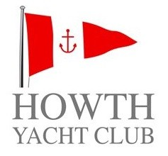 | LAMBAY RACES 2021

PROTEST TIME LIMIT

DATE
Saturday 12th June 2021

PROTEST TIME LIMITS
Offshore Fleet _______

Inshore Fleet _______

PROTEST HEARING LOCATION:
Centenary Room, 2nd Floor of the Clubhouse

