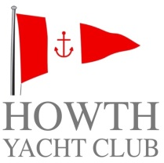
Brass Monkeys
NO. | WIND | COURSE | DISTANCE
1 | N | Hp, Wp, Ip, Hp, Ip, Hp, Wp, Is, F. | 8.5
2 | N | Hp, Wp, Ip, Hp, Wp, Is, F. | 6.5
3 | N/E | Hp, Wp, Cp, Hp, Cp, Hp, Wp, Is, F. | 9.1
4 | N/E | Hp, Wp, Cp, Hp, Wp, Is, F. | 6.4
5 | E | Dp, Hp, Wp, Ip, Vp, Wp, Is, F. | 6.5
6 | E | Dp, Hp, Wp, Ip, Vp, Is, F. | 5.2
7 | S/E | Ip, Pp, Ip, Dp, Pp, Is, F. | 7.5
8 | S/E | Ip, Pp, Ip, Dp, Vp, Is, F. | 5.4
9 | S | Ip, Dp, Hp, Ip, Dp, Hp, Ip, Hp, Is, F. | 7.7
10 | S | Ip, Dp, Hp, Ip, Dp, Hp, Is, F. | 5.6
11 | S/W | Cp, Dp, Hp, Cp, Dp, Hp, Cp, Is, F. | 8.3
12 | S/W | Cp, Ip, Hp, Cp, Hp, Cp, Is, F. | 7.3
13 | W | Wp, Cp, Dp, Wp, Dp, Wp, Is, F. | 7.6
14 | W | Wp, Cp, Dp, Wp, Cp, Is, F. | 5.1
15 | N/W | Pp, Wp, Ip, Pp, Wp, Cp, Wp, Is, F. | 7.3
16 | N/W | Pp, Wp, Cp, Wp, Cp, Wp, Is, F. | 5.1

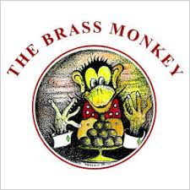

Brass Monkeys
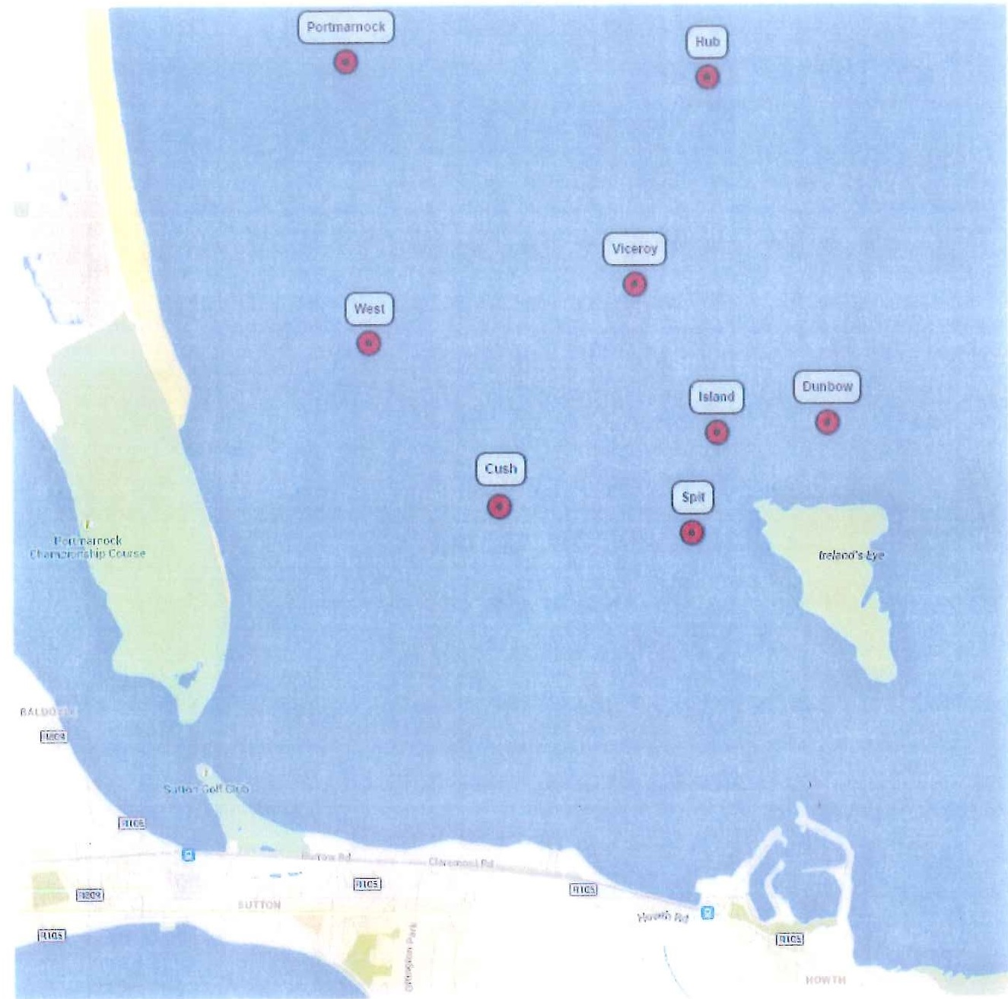
Image not to scale and should not be used for navigational purposes
Mark | ID | North | West
Cush | C | 53 24.5 | 06 05.44
Dunbo | D | 53 24.73 | 06 03.85
Hub | H | 53 25.71 | 06 04.43
Island | I | 53 24.7 | 06 04.39
Portmarnock | P | 53 25.76 | 06 06.18
Spit | S | 53 24.42 | 06 04.51
Viceroy | V | 53 25.12 | 06 04.78
West | W | 53 24.96 | 06 06.07

