 | Howth Yacht Club  OPEN LASER FROSTBITES NEW YEAR’S DAY RACE  2019  Organised by Howth Yacht Club. | 

If you have entered for the 2018 Winter series or both series (2018 Winter and 2019 Spring)
you don’t need to fill in this form as the fee is included in your entry for these events

ENTRY FORM

Name ____________________________________________________________________________________

Address ____________________________________________________________________________________

____________________________________________________________________________________

Contact No. __________________________ EMail _________________________________________________

Date of Birth _________________________ Club __________________________________________________

Sail No. _________________________ Rig: Standard Radial 4.7
(Please tick as appropriate)
ENTRY FEE: €10.00

I declare that:
- I agree to be bound by the Racing Rules of Sailing, the prescriptions of the ISA, the Notice of Race, the Sailing Instructions, any amendments thereto and the relevant Class Rules.
- I acknowledge that I enter and sail at my own risk and that Howth Yacht Club is not liable for any loss or damage to boats or equipment or injury to persons.
- I am fully aware of the actual and potential risks involved in active water sports, including drowning, hypothermia and other physical injuries. I accept that, by engaging in active water sports, my physical safety and that of my crew could be endangered. I am also aware that other competitors’ actions and the actions or inaction’s of the organisers of water sports events, including the drivers of escort craft, can also endanger my physical safety.
- I have a valid and adequate third party liability marine insurance policy and I further confirm that this policy will remain in full force and effect for the duration of the event.
- I acknowledge that it is up to me personally to assess whether any event or activity on the water is too difficult for me. I acknowledge that the safety of my yacht and its entire management including insurance is my sole responsibility and I am satisfied that the yacht and helm are adequate to face the conditions that may arise in the course of the races.

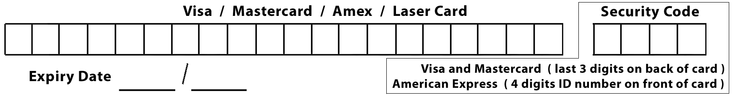

I enclose Laser / Credit Card details / Cheque payable to Howth Yacht Club for € ________

Signed _________________________________________ Date _______________________
Parent or guardian if under 18 years

Entry form with correct remittance to reach
Secretary, Howth Yacht Club, Middle Harbour, Howth, Co Dublin
before competing in the race

