 | Howth Yacht Club  Brass Monkeys  Spring Series 2019 | 
Entry Form

Enter online at http://hyc.ie/ or send this form, together with cheque or credit card details to:
Hon. Sailing Secretary, Howth Yacht Club, Harbour Road, Howth, Co. Dublin.

First Warning Signal 1025

Boat Name _____________________________________ Sail No. ______________________

Boat Type ________________________________________________________________________

Boat LOA (metres) _________________ Boat LWL (metres) ______________________

Non Spinnaker |  | Please tick if you wish to race in a Non-Spinnaker division

Owner Name _____________________________________

Address ________________________________________________________________________

________________________________________________________________________

Contact telephone number _____________________________

Email address _____________________________________________________________________

Entry Fee € 40.00 Remittance Enclosed ____________

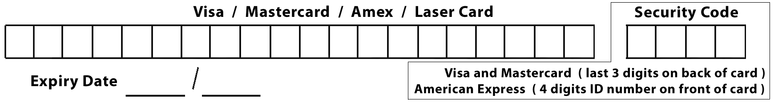

I agree to be bound by the Racing Rules of Sailing, the prescriptions of the ISA, Notice of Race, the Sailing Instructions (and any amendments thereto).

I declare that my yacht is suitable for racing in winter conditions and that it shall be manned by a competent skipper and crew during each race. I confirm that my sail number will be displayed on my sails.

I acknowledge that I enter at my own risk and that neither the sponsors nor Howth Yacht Club, its servants or agents, will be liable for any loss, damage to yachts and equipment, or death or personal injury, howsoever caused to the skipper, owner, crew or other competitors, as a result of taking part in the race or races. I am aware of the recommendations of the ISA Safety Guidelines.

I confirm that my boat carries adequate, valid, third party, liability insurance cover.

Owner / Representative : Signed ____________________________ Date _________________

Closing date for entries - Thursday 24th January after 1700 hours. Entries received after this date may be accepted at the discretion of the Organising Authority.

