 | Howth Yacht Club  Brass Monkeys  New Years Day Race 2019  Tuesday, 1st January | 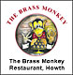
This race is in aid of the Lifeboat and prizes sponsored by the Brass Monkeys Restaurant

Entry Form

Warning Signal 1125

Items marked * MUST BE COMPLETED

Boat Name _____________________________________ Sail No. ______________________

Boat Type ________________________________________________________________________

Boat LOA ______________________ Boat LWL ______________________

THIS IS A SINGLE CLASS, NON SPINNAKER, EVENT

Owner Name _____________________________________

Address ________________________________________________________________________

________________________________________________________________________

Contact No _____________________________

Email ________________________________________________________________________

Entry Fee : € 20.00 Remittance Enclosed _____________

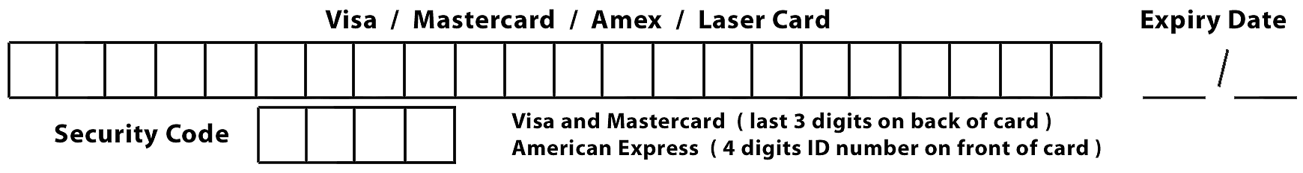

I agree to be bound by the Racing Rules of Sailing, the prescriptions of the ISA, Notice of Race, the Sailing Instructions (and any amendments hereto) and the relevant class rules.

I declare that my yacht is suitable for racing in winter conditions and that it shall be manned by a competent skipper and crew during each race. I confirm that my Sail Number will be displayed on my sails.

I acknowledge that I enter at my own risk and that neither the sponsors nor Howth Yacht Club, its servants or agents, will be liable for any loss, damage to yachts and equipment, or death or personal injury, howsoever caused to the skipper, owner, crew or other competitors, as a result of taking part in the race or races. I am aware of the recommendations of the ISA Safety Guidelines.

Signed ___________________________________________ Date _________________________

Sailing Instructions will be available from the Marina Office
on Tuesday 1st January 2019 .

Closing Date for entries – Thursday 27th December 2018

