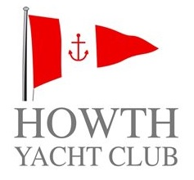 | HOWTH YACHT CLUB  GIBNEY CLASSIC 2018  Organised by Howth Yacht Club Ltd.  Saturday 4th August 2018

SAILING INSTRUCTIONS

- RULES:
Races shall be sailed under the Racing Rules of Sailing (RRS), ISA Prescriptions, the Rules of each class concerned, the Notice of Race except as modified by the Sailing Instructions, these Sailing Instructions and any amendments thereto.
The Gibney Classic will be the scoring race for HYC Club Racing on Saturday, 4th August 2018.

- NOTICE TO COMPETITORS:
The Official Notice Board is located in the archway beside the HYC Marina Office.

- ALTERATIONS TO SAILING INSTRUCTIONS AND/OR NOTICE OF RACE:
Flag L displayed on the flag pole at the top of HYC Marina Bridge denotes that a change of Sailing Instructions and/or Notice of Race has been made, details of which are posted on the Official Notice Board. Any change in the Sailing Instructions and/or Notice of Race will be displayed at least 1.5 hours before the scheduled start of the first race so affected. For those boats leaving Malahide to compete, any changes to SI will be communicated via the Malahide YC Commodore.

- TIDE TIMES:
L.W (Howth): 11.02 (1.02m)
H.W. (Howth): 17.31 (3.39m)

- SCHEDULE OF RACES:

Class | Class Flag | Warning  Signal | Start
Class 1/2 | No. 1 and No.2 | 1330 | 1335
Non Spinnaker Cruiser | No. 4 | 1335 | 1340
Class 3 / J80 | No. 3 | 1340 | 1345
Puppeteer 22 | A | 1345 | 1350
Howth 17 Footer | C | 1350 | 1355
Squib | K | 1355 | 1400

- STARTING AREA:
The starting area will be North of Howth. Starts will be from a Committee Boat flying an orange flag.

- STARTING LINE:
The starting line shall be between the red and white pole or main mast of the Committee Boat and an orange outer limit mark.

- STARTING SIGNALS:
Starts shall be in accordance with RRS 26.

- COURSES:
Courses for the Gibney Classic shall be as per the HYC WEDNESDAY COMMITTEE BOAT COURSE CARD, [Appendix 1]. MARK DESCRIPTIONS shall be as per Appendix 2. These Appendices form part of these Sailing Instructions.

- COURSE DESIGNATION: Courses shall be designated by numerals displayed on boards on the Committee Boat. The course applicable to each race will be displayed for not less than 4 minutes before its start. This changes RRS 27.1.

- FINISHING LINE:
The Finishing Line shall be between the red and white pole or main mast of the Committee Boat displaying a blue flag and an orange Finish Mark. Unless the course is shortened, the Finish line will be located in the vicinity of the entrance channel to Malahide Estuary.

- RE-CROSSING START/FINISH LINES:
All boats shall keep clear of the starting line until their warning signal. Boats having started shall keep clear of the starting line while other starts are in progress.

- STARTING TIME LIMIT:
A boat shall not start later than 15 minutes after her valid starting signal.

- FINISHING TIME LIMIT:
The time limit for the leading boat in each Class shall be 2½ hours from their starting signal. If a boat in a class finishes within this limit, the time for that class shall be extended by 30 minutes. Any boat which fails to finish within the time limit will be scored DNF, Did Not Finish. This changes RRS 35 and A4.1.

- PROTESTS:
15.1 Boats intending to protest shall notify and receive acknowledgement from the race finishing boat within 1 hour of the last boat finishing time in the relevant division/fleet.
15.2 Protests shall be heard after racing, at Gibneys Malahide.
Please contact Sam O’Byrne on 087 2708989

- SAFETY:
Competitors participate entirely at their own risk; see Fundamental Rule 4, Decision to Race and the ISA Safety Booklet. Open boat entrants are referred to relevant class regulations. The wearing of personal flotation devices in all boats is strongly recommended at all times. The responsibility for the safety of competing boats and their crews lies solely with the said competitors. Howth Yacht Club Ltd. and/or the Organising Committee will not accept any liability for material damage, personal injury or death sustained in conjunction with, prior to, during, or after racing.

- INSURANCE:
Each participating boat shall be insured with adequate valid third party liability insurance.

- RADIO COMMUNICATION:
Competitors are advised to keep a listening watch on VHF, Ch. 69 where information relevant to racing may be broadcast. Should this information be broadcast, it shall not constitute outside assistance and shall not be the subject of any protest. Failure to broadcast this information shall not be the basis for any claim for redress. Competitors who retire from a race are required to inform the Race Committee promptly by radio on Channel 69.
 | 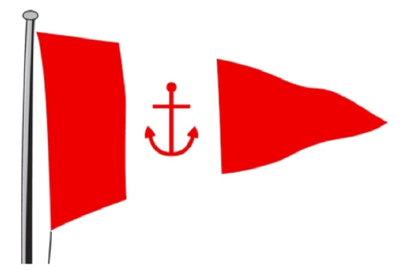 | WEDNESDAY APPENDIX 1
 |  | HYC COMMITTEE BOAT COURSE CARD
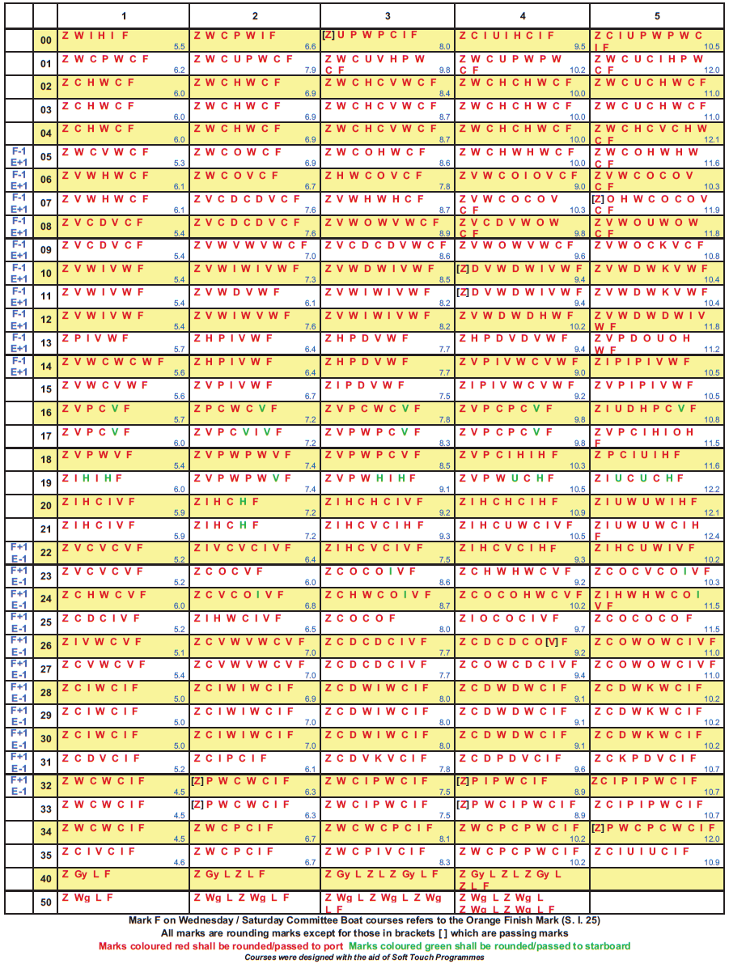
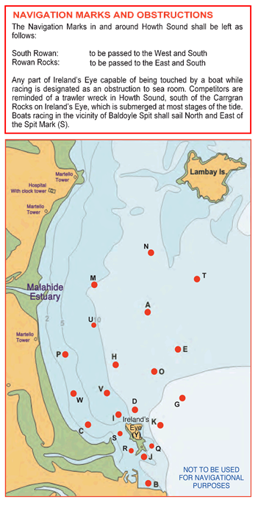 |  |  | APPENDIX 2
 |  |  | 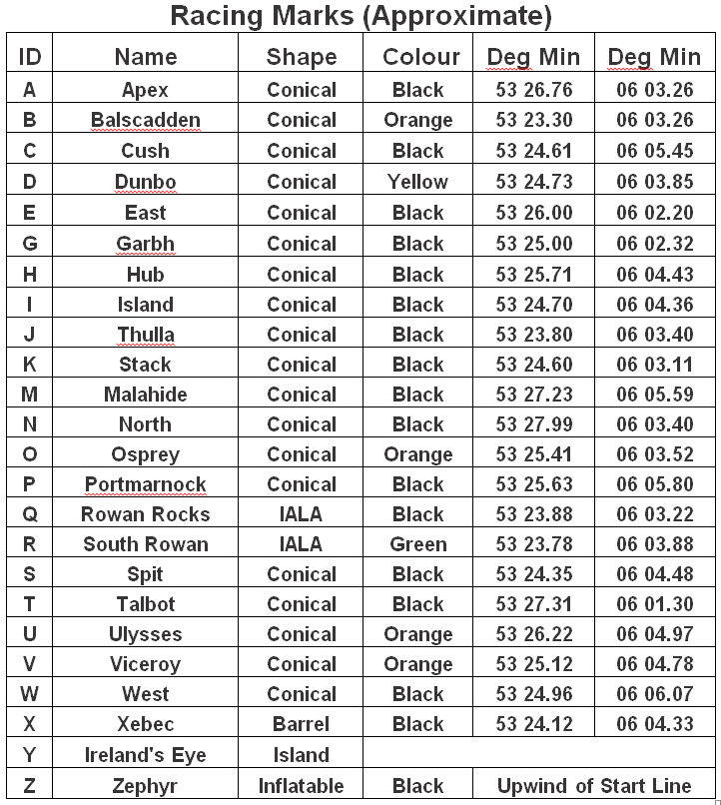
 |  |  | 