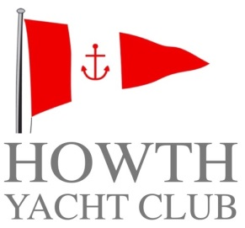

Junior
Membership Application Form

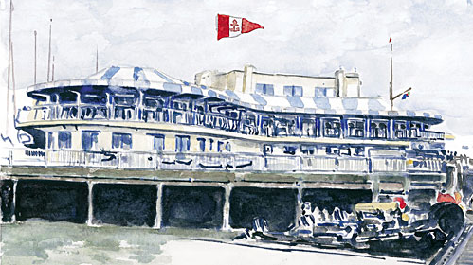
SUBSCRIPTION RATES 2017

FAMILY €1100.00

ORDINARY (Over 32 years) €820.00
ORDINARY ((aged 30 & over 31) €525.00
ORDINARY (aged 28 & 29) €340.00
ORDINARY (aged 25 to 27) €175.00

ASSOCIATE €210.00

CADET (aged 19 to 24 inclusive) €125.00

COUNTRY €240.00

OVERSEAS €50.00

SENIOR €400.00

JUNIOR €105.00

2017 Introductory €300.00
(T&Cs apply)

For more information please contact

Howth Yacht Club
Middle Pier
Howth
Co Dublin

01 832 2141
office@hyc.ie

hyc.ie
Howth Yacht Club Membership 2017
Every candidate for Ordinary, Associate, Cadet or Country Membership must be 18 years of age and must be proposed and seconded by an Ordinary, Honorary or Senior Member, to both of whom he or she has been personally known for at least one year, and the candidate must also be known to, and recommended by, a member of the General Committee.

Completed application form, together with letter of recommendation from proposer, shall be sent to the Honorary Secretary. As Membership for the Club runs from January to December, your Membership is due for renewal at the start of the calendar year.

SENIOR - is open to members who have 10 years continuous Ordinary membership and are aged 66 years or over.
ASSOCIATE - is open to candidates who are spouses, widows or widowers of Honorary, Senior or Ordinary Members.
CADET - is open to candidates 19 to 24 years of age inclusive.
JUNIOR – is open to candidates 7 to 18 years of age inclusive.
COUNTRY - is open to candidates who are resident outside a radius of 60 kilometres of Howth or who are voting members of any Yacht Club with which Howth Yacht Club has a reciprocal membership agreement.
FAMILY - is made up of one Ordinary member, one Associate member and unlimited Junior members all from the same family.
2017 Introductory – is limited to candidates who have not been an ordinary member since 31st December 2013.

PAYMENT DETAILS

Please find enclosed Cheque Cash

IN THE AMOUNT OF €

Please debit my Amex / Mastercard / VISA / VISA DEBIT

EXPIRY CCV

Signature

Date
For Office Use Only

Have you previously been a member? If so, give details.
Address
Full Name
Date of Birth
Please list members of your family who are HYC Members, if any.
Gender

Parents Name
Please list other Yacht Clubs of which you are a Member, if any.

Parents Signature
Mobile
Daytime No.
Email
Please give a brief history of your Sailing experience or and aspirations.
Insert photo here

DATE RECEIVED

DATE CLEARED FOR THE NOTICEBOARD
SIGNATURE
JUNIOR ORGANISER
Date approved

MEMBERSHIP NUMBER / FAMILY ID / WEB ID
DATE OF ELECTION
SIGNATURE
SECONDER
BLOCK CAPITALS
SECONDER
PROPOSER
PROPOSER PLEASE ENCLOSE LETTER OF RECOMMENDATION
PROPOSER
BLOCK CAPITALS
SIGNATURE

