Howth Yacht Club ‘Introductory Membership’ 2017
- Annual Introductory Membership permits the use of the Club from 1st January to 31st December

- Introductory Members are encouraged to use the ‘top up’ facility on their Membership Cards for use at the bar and in the club offices

- Introductory Members enjoy members’ discounted pricing throughout the club.

- This category of membership is limited to candidates who have not been an Ordinary Member of Howth Yacht Club since 31st December 2013
- The completed application form is sent to the Honorary Secretary along with a letter of recommendation from proposer or Membership Committee

- As Membership for the Club runs from January to December, your membership will be due for renewal at the start of each calendar year

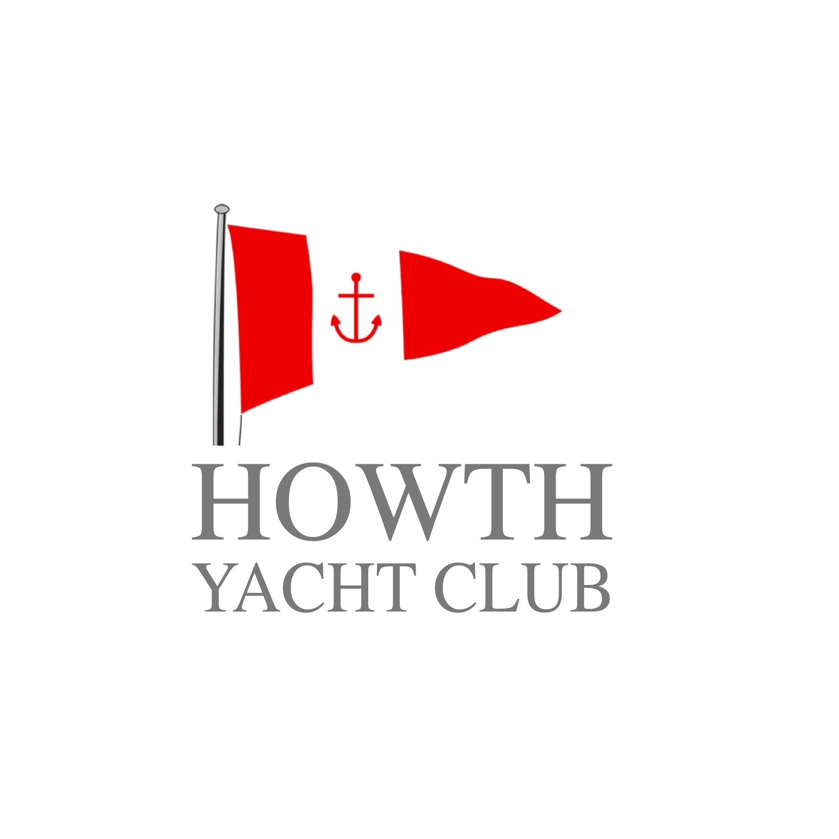
Introductory Membership Form

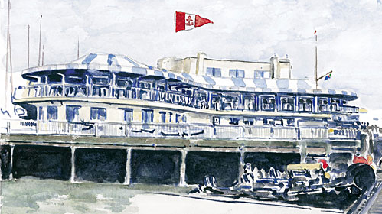

Introductory Membership 2017
€300

For more information please contact:

Howth Yacht Club
Middle Pier
Howth
Co Dublin

01 832 2141

office@hyc.ie

hyc.ie

Have you previously been a member? If so, give details:
Full Name
Address

PAYMENT DETAILS:
Please find enclosed Cheque Cash

IN THE AMOUNT OF €300.00
Please debit my Amex / Mastercard / VISA / VISA DEBIT

EXPIRY CCV

Signature

Date

For Office Use Only:

Please list members of your family who are HYC Members: (if any)
Date of Birth
Occupation
Company
Mobile
Please list other Yacht Clubs of which are are a member: (if any)
Daytime no.
Email

Please give a brief history of your sailing experience and/ or aspirations:
Insert photo here

Did you present yourself for interview by the Membership Committee (if no Proposer)?
SIGNED BY MEMBERSHIP COMMITTEE
SECONDER
SIGNATURE
BLOCK CAPITALS
SIGNATURE
BLOCK CAPITALS
PROPOSER
YES / NO
DATE COMPLETED

DATE CLEARED FOR THE NOTICEBOARD
DATE RECEIVED
DATE OF ELECTION
MEMBERSHIP NUMBER / FAMILY ID / WEB ID
OF THE GENERAL COMMITTEE
RECOMMENDED AND SIGNED BY
ON BEHALF OF THE GENERAL COMMITTEE

ON BEHALF OF MEMBERSHIP COMMITTEE
(PROPOSER MUST ENCLOSE LETTER OF RECOMMENDATION)

