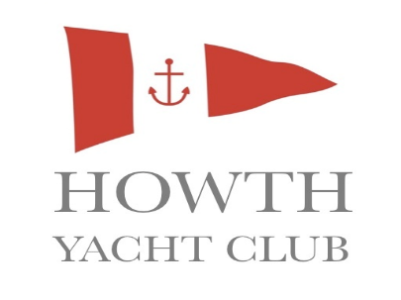

OPENING TIMES
THURS 12:30-21:00 FRI 12:30-21:00
SATURDAY 12:30-21:00 SUNDAY 12:30-18:00

Starters/Snacks Mains
Soup of the Day Open Steak Sandwich
Served with Home-made Brown Bread Grilled Steak topped with Caramelised Onions
€4.50 Served on a Fresh Ciabatta Roll with House Fries
Seafood Chowder €14.50
€6.00 Chargrilled Swiss Burger
Bruschetta 100%Irish Beef, Grilled to Perfection. Topped with
Tomato &Fresh Mozzarella with Mixed Salad Pickle, Swiss Cheese, Rocket Salad & Fresh Tomato
€6.50 Served with House Fries
Chicken Wings €9.50
Tossed in a Hot Spicy Sauce Chicken & Mushroom Vol Au Vent
€7.50 Large €11.50 Small €7.95
Open Crab Salad Margherita Pizza
Fresh Crab served on Home-made Brown Bread Mozzarella Cheese & Tomato Sauce
€8.50 €10
Smoked Salmon Platter Pizza of the Day
Served with Mixed Greens, Potato Salad & Fresh Avocado €12.50
€8.50 SIDES
Grilled Chicken Salad House Fries
Chicken with Mixed Leaves & Fresh Avocado €3.00
€8.95 Deep Fried Home-made Onion Rings
€3.50
SIDES House Mixed Salad
Garlic Bread €4.00
€4.00
Garlic Bread with Cheese
€4.50
Desserts…..Please ask your Server about our Delicious selection of Desserts €5.00


Children’s Menu
Slider
3oz Beef Burger served on a Bun with HYC Chips
€7.00
Fish & Chips
Freshly Battered Fish Portion, Deep Fried & served with HYC Chips
€7.95
Sausage with a Choice of Mashed Potatoes OR HYC Chips
€7.50
Fresh Pasta with a Choice of Tomato Sauce, Butter OR Olive Oil
€6.95
Home-made Meatballs in a Fresh Tomato Sauce with Pasta OR Chips
€8.50
Thin & Crispy Pizza
Choose your Favourite Toppings
€8.00
Desserts
Jelly & Ice-cream
Chocolate Brownie
Ice-cream Bowl
€5.00


