2002

INTERNATIONAL MIRROR CLASS

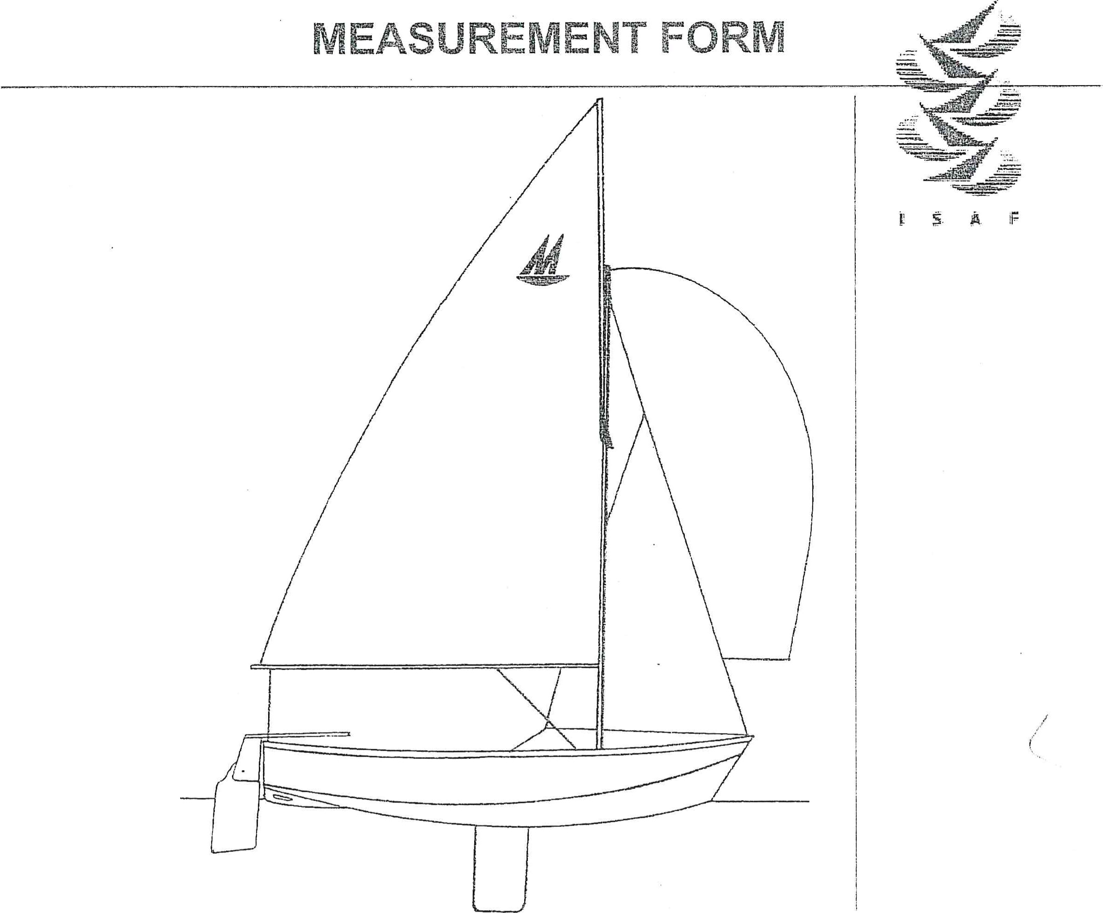

INCLUDING THE

# MEASUREMENT CERTIFICATE

Authority: International SaiEing Federation

ISAF Plaque

|  |  |  |  |  |  |  |  |  |  |
| --- | --- | --- | --- | --- | --- | --- | --- | --- | --- |
|  |  |  |  |  |  | | ACTUAL | | MAX |
|  | | |  | | | | | |
|  | 1.1 | Do the hull materiaEs comply with ruie Part B —  Measurement Rufes 1.1? (For GRP hulls see below) |  | | Yes/ o | | |  |
| 2 | 14.4 | Distance around underside of hull from the Aft Measurement Point to:  Forward Measurement Point eertreboar | 3078 | |  | | | 3098 |
|  | 3 | I .4.1 | Distance from basefine to outside of hull shell, on centre!ine including kee\band:  Section 0 |  | | 220 | | |  |
| Section 1 | 98 | |  | | | 118 |
| Section 2 | 28 | |  | | | 48 |
| Section 3 |  | |  | | | 54 |
| Section 4 | 66 | |  | | | 86 |
| Forward Measurement Point |  | | 250 | | |  |
| Es the slope centreboard of less than 1 in 20? |  | | Yes/Nfå | | |  |
| 4 | 1 .4.2 | Does the transom comply with rule 1.4.2? |  | | Yes/No | | |  |
| 5 | 't .43 | Width of outside of each bottom panei, from hufl centre}ine to chine (A) at:  Section 0 |  | | port | | Starboard | 488 |
| Section 1 | 570 | |  | |  | 586 |
| Section 2 | 606 | |  | |  | 622 |
| Section 3 | 587 | |  | |  | 603 |
| Section 4 | 555 | |  | |  | 571 |
| 6 | 1.43 | Distance from horizontaf line touching the keelband to chine (C) at:  Section Q | 52 | |  | |  | 68 |
| Section 1 | 60 | |  | |  | 80 |
| Section 2 | 110 | |  | |  | 130 |
| Section 3 | 193 | |  | |  | 213 |
| Section 4 | 230 | |  | |  | 250 |
| 7 | I .4.3 | Distance from horizontal line to sheertine (D) at: Section O | 302 | |  | |  | 322 |
| Section 1 | 403 | |  | |  | 433 |
| Section 2 | 484 | |  | |  | 514 |
| Section 3 | 510 | |  | |  | 540 |
| Section 4 | 505 | |  | |  | 535 |

ISAF Plaque Number: 4.0.319

|  |  |  |  |  |  |  |  |  |
| --- | --- | --- | --- | --- | --- | --- | --- | --- |
|  | 8 | .4.7 | Cutvature of bottom panets at: Section 0 | 3 | port | Stbd | | 9 |
| Section 1 | -3 |  |  | | 3 |
| Section 2 | 3 |  |  | | 13 |
| Section 3 | 3 |  |  | | 13 |
| 9 | 1 .4.8 | Are the radii of chines between sections 0 and 3 less than 1 Omm |  | Yes/No | | |  |
|  | 1.4 |  |  |  | | |  |
|  | 11 | .4.6 | Beam of bow transom:  275 mm from FMP | 405 |  | |  |  |
| 475 mm from FMP | 550 |  | |  |  |
| 12 | .4.9 | Bilge keefs:  Length over which cross section is not less than 9mm high and i3mm wide | 915 | port | Stbd | |  |
|  |  | |
| Distance of centreline of bilge keeis from hull centreiine | 375  port  Starboard | Max | Min | | 435 |
|  |  | |
|  |  | |
| Distance from aft transom to aft end of keels | 730 |  | | | 790 |
| 13 | 1.1.10 | Overall length of skeg | 635 |  | | |  |
|  | 1.4.10 | Depth of skeg (including keelband) 76mm from section 0 | 64 |  | | |  |
| 305mm from Section 0 | 51 |  | | |  |
| 457mm from Section 0 | 32 |  | | |  |
| 15 | 1.4.10 | Thickness of skeg at hull | 18 |  | | |  |
| 16 |  | Length of hole in skeg | 132 |  | | | 152 |
| Height of hole in skeg | 18 |  | | | 28 |
| Fairing of hole in skeg |  |  | | | 25 |
| AMP to hole in skeg | 185 |  | | | 215 |
| Hull surface to hole in skeg | 10 |  | | | 20 |
| 17 | 1.4. I l | Length of centreboard slot in the underside of hull | 381 |  | | | 405 |
| 18 |  | Width of centreboard slot |  |  | | | 19 |
| 19 |  | Depth of centreboard case | 283 |  | | |  |
| Projection of centreboard when fully down |  |  | | | 610 |
| 20 | 1 .4.12 | Width of outer gunwales | 12 |  | | | 18 |
| Depth of outer gunwales | 25 |  | | | 31 |
| Is the radii of the outer gunwales 15mm or less? |  | Yes/No | | |  |

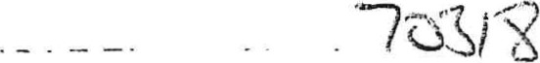

|  |  |  |  |  |  |  |  |  |  |
| --- | --- | --- | --- | --- | --- | --- | --- | --- | --- |
|  | 21 | 104.13 | Length of stem post | 200 |  | | |  |  |
| Thickness of stem post | 15 |  | | |  |  |
| 22 | .4.14 | Do the holes in the transom comply with rule 1.4.14? |  | Yes/No | | |  |  |
| 23 |  | Does the hull shell comply with rule 1.4.15? |  | Yes/No | | |  |  |
| 24 | 1.5.1 | Does the keelband comply with rute 1 ,5.1? |  | Yes/No | | |  |  |
| 25 | 1.5.2 | Do the rudder fittings comply with rule 1.5.2? |  | Yes/No | | |  |  |
|  | 26 | .5.5 | Does the hutt comply with rule 1.5.6? |  | Yes/No | | |  |  |
|  | | | | | | |  | |
| 27 | 1.2 | Does the construction comply with rule 1.2? |  | Yes/No | | |  | |
| 28 | 't .4.3 | Beam at sheerline (B) at:  Section 0 | 1053 |  | | | 1073 | |
| Section | 1264 |  |  | | 1304 | |
| Section 2 | 1362 |  | | | 1402 | |
| Section 3 | 1276 |  | | | 1316 | |
| Section 4 | 1152 |  | | | 1192 | |
|  | 1 .6 1 | Length overall, excfuding rudder fittings | 3285 |  | | | 3325 | |
| 30 | 1.6.2 | Distance from fon«ard face of the aft transom to fongvard face of aft bukheed | 395 |  | | | 455 | |
| 31 | 1.6 3 | Distance from forward face of aft transom to aft face of stowage compartment buEkhead | 2085 |  | | | 2115 | |
| 32 | .6.4 | Distance from fon«ard bulkhead to stowage compartment bukhead | 300 |  | | | 340 | |
| 33 | 1.6.13 | Fomtard face of aft transom to centre of aft mast step | 2145 |  | | | 2175 | |
| Thickness Mast Step |  |  | | | 12 | |
|  | 1.6, 14 | Aft face of aft transom to centre of shroud block | 1808 |  | | | 1838 | |
| 35 | 1.7 1 | Do the shroud attachment fittings comply with rule 1.7.1? |  | Yes/No | | |  | |
| 36 | 1.6 5 | Distance between side tank panels at: Aft bulkhead | 735 |  | | | 765 | |
| Stowage compartment bulkhead | 735 |  | | | 765 | |
| 37 | 1.6.6 | Depth of side tanks at: Aft bulkhead | 200 |  | | Stb | 230 | |
| Stowage compartment bulkhead | 260 |  | |  | 290 | |
| 38 | 1 .6 7 | Does the decking comply with rule 1.6.7? |  | Yes/No | | |  | |
| 39 | 1.6.8 | Width of thwart | 142 |  | | |  |  |
| Thickness of thwart | 13 |  | | |  |  |
| Width of centreboard slot in thwart |  |  | | |  | 19 |
| Transverse length of thwart | 805 |  | | |  | 835 |

 70313

|  |  |  |  |  |  |  |  |  |  |
| --- | --- | --- | --- | --- | --- | --- | --- | --- | --- |
|  |  |  | Distance from aft edge of thwa<c to foncvard face of aft transom | |  | |  | | 1365 |
| 40 | 1.6.9 | Do the inspection hatches comply with rule i .6.9? | |  | |  |  | |
| 41 | i.6.i0 | Do the drain holes comply with rule 1.6. IQ? | |  | | Yes/No |  | |
| 42 | 1.6.ä1 | Width of inner gunwales | |  | |  | 23 | |
| Depth of inner gunwales | | 25 | |  | 31 | |
| Is the radii of the outer gunwales 15mm or less? | |  | | Yes/No |  | |
|  |  |  | oor a ens comp y wtl rue | .6. 2? |  | | Yes/No |  | |
| 44 | 1.6.15 | Transom thickness | | 22 | |  | 28 | |
| 45 | .6.16 | Does the interior comply with rule 1.6.i 6? | |  | | Yes/No |  | |
| 46 | 17.2 | Does the forestay attachment fitting comply with rule 1.7.2? | |  | | Yes/No |  | |
| 47 | i .7.3 | Do the headsail sheet fairieads and mounting blocks comply with rule 1.7.3? | |  | |  |  | |
| 48 | I .74 | Does the headsail tack attachment comply with rule 1.7.4? | |  | | Yes/No |  | |
| MEASURER'S DECLARAT}ON - HULL | | | | | | | | |
| For Wood HuEEs: Plaque No•  I certify that have taken the measurements recorded on this form and that, to the best of my_knowledge, they conform to the rufes of the laternationai Mirror C}ass at present in forcesubjecttöany comments below:  Comments:  Name:  Signature:  Date: | | | | | | | | |
| For GRP Plaque No:  ! certify that t have taken the measurernents recorded on this form and that, to the best of my knowledge, they conform to the rules of the International Mirror Class at present in force, subject to any comments on this form.  Note: The measurer need only take as many measurements as he feels necessaty to satisfy himself that to the best of his knowledge the boat has been built in the approved moulds stated in the builders declaration. (tem numbers 3, 5 (section 2), 6 (section 2), 7 (section 2), 28 and 33 must be measured for all boats.  Name:  Signature:Date:  Officiafly  .. | | | | | | | | |
|  | | | | |  | | | |



|  |  |  |  |  |  |  |  |
| --- | --- | --- | --- | --- | --- | --- | --- |
|  | CENTREBOÅRD | | | | | | |
| 49 | 2.1 | Does the centreboard campfy with rule 2.1? |  |  | |  |
| 50 | 2.2 | Width of centreboard: At top | 260 | 8-71 | | 320 |
| Below cut off corner | 356 | 3Co | | 380 |
| 51 | 2.2 | Are the radii of bottom corners between 30 and 50 |  | Yes/" | |  |
| 52 | 2.2 | Thickness of centreboard |  |  | | 14 |
|  |  |  | t o airing from any edge |  | 40 | | 50 |
| 54 | 2.2 | Depth of cut off |  | (I D | | 165 |
|  | | | | | | |
| 55 | 3.1 | Does the rudder comply with rule 3.1 ? |  | yes/"- | |  |
| 56 | 3.2 | Distance from centre of pivot:  Aft corner of rudder bEade | 545 |  | | 575 |
| Lower edge of rudder blade measured paraE[eE to leading edge | 495 | 525 | | 525 |
| Underside of tiller measured parallel to feeding edge of rudder stock | 204 |  | | 228 |
| 57 | 3.2 | Width of rudder blade | 265 | 280 | | 295 |
| 58 |  | Thickness of rudder bfade |  |  |  | 14 |
| 59 | 3.2 | Width of fairing from any edge |  |  | | 25 |
| 60 | 3.2 | Are the radii of bottom corners less than 50mm |  | yes/% | |  |
| MEASURER'S DECLARATÅON - Centreboard and Rudder | | | | | | |
| To be signed by the measurer(s):  I certify that I have taken the measurements on this form for the centreboard and rudder and that, to the best of my knowledge, they conform to the rules of the International Mirror Class at present in force.  Name:  Signature:Date:  Officially | | | | | | |
|  | | |  | | | |

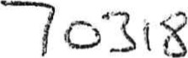



|  |  |  |  |  |  |  |
| --- | --- | --- | --- | --- | --- | --- |
|  | | | | | | |
| 61 | 5.1.i | tvtast  Overatt length of mast |  | gaqr2 | | 3296 |
| 62 | 5.i.5 | Base of mast to main halyard sheave bearing surface |  | 32 oo | | 3200 |
| Does the main halyard sheave compty with rule 5.1.5? |  | Yes/24 | |  |
| 63 | 5.1.6 | Base of mast to top of boom | 659 |  | | 679 |
| 64 | 5.1.7 | Weight of mast | 2.7kg |  | |  |
|  | 5.1.8  5.1.9  5.1.10 | Does the mast comply with rule 5.1.8, 5.1.9 end 5.1.10? |  | Yes/>' | |  |
| 66 | 5.1.2 | Does the mast compiy with rule 5.1.2? |  | Yes/ | |  |
| 67 | 5.1.3 | Does the mast comp!y with rule 5.1.3? |  | Yes/ | |  |
| 68 | 5.1.4 | Diameter of wood mast | 44 |  | | 56 |
| Diameter of aluminium mast | 47 | SO | | 53 |
| 69 | 52.1 | Boom  Overall length of the boom excluding fittings | 2235 | RZÖ | | 2285 |
| 70 | 52.4 | Distance from inner end of boom to opposite side of kicking strap block | 483 |  | |  |
| 71 | 5.2.2 | Does the boom compey with rule 5.2.2? |  | Yes/ o | |  |
| 72 | 52.3 | V%ftith of boom | 37 |  | | 43 |
| Depth of boom | 37 |  | | 43 |
| 73 | 5.2.5 | Does the boom compty with rule 5.2.5 and 5.2.6? |  | Yes/ o | |  |
| 74 | 5.3.1 | Gaff  Length of gaff measured along the stot |  |  | | 2809 |
| 75 | 5.3.2 | Does the gaff comply with rule 5.3.2? |  | Yew | |  |
| 76 | 5.3.3 | Periphery of gaff: At peak | 102 |  | |  |
| At gaff band | 146 | 1!5 7__ | |  |
| 204mm from lower end | 127 |  | C) |  |
| Fore and aft dimension |  | 3 | | 45 |
| 77 | 5.3.4 | Does the gaff comply with rule 5.3.4? |  |  | |  |
| 78 | 5.3.5 | Does the painted band comply with rule 5.3.5? |  | Yes/No/ | |  |
| 79 | 5.3.6 | Top of gaff to tower edge of either the gaff band or pin |  |  | | 1733 |
| 80 | 5.4. 'l | Spinnaker poke. etc  Overall length of spinnaker pole or jib stick |  |  | | 1524 |
| 81 | 5.4.2 | Do the spinnaker pole and jib stick compiy with rule 5.4.2? |  | Yes/ | |  |



|  |  |  |  |  |  |  |
| --- | --- | --- | --- | --- | --- | --- |
|  | 82 |  | Does the rigging comply with rule 6.1.1? |  |  |  |
| 83 | 6.1.2 | Does the rigging comply with rule 6.12? |  | Yes/N4 |  |
| 84 | 6.1.3 | Does the forestay comply with rule 6.1.3? |  | Yes/fqo |  |
| 85 | 6.1.4 | Do the shrouds compfy with rule 6.1.4? |  | Yes/No |  |
| 86 | 6.2.1 | Running Riqqina  Does the running rigging comply with rule 6.2.1? |  | Yes/Np |  |
|  | | | | | |
|  | 87 |  | Does the boat comply with rule 9.1? |  | Yes/ls(Q |  |
| 88 | 9.2 | Does the boat comply with rule 9.2? |  | Yes/h(o |  |
|  | | | | | |
| To be signed by the measurer(s):  I certify that have taken the measurements on this form for the spars and rigging and that, to the best of my knowledge, they conform to the rules of the International Mirror Class at present in force, except as stated below:  Comments:  Name:  Signature: | | | | | |

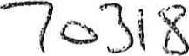

|  |  |  |  |  |  |  |  |  |
| --- | --- | --- | --- | --- | --- | --- | --- | --- |
| BUOYANCY ENDORSEMENT | | | | | | | | |
| This boat cornpfied with the buoyancy test conducted in accordance with the CEass Rules:  Measurer's Signature:  Date: a  9<04 | | | | | | | | |
|  | |  | | | | | | | | |
| Weight of boat at measurement (Exc. Corectors) | | | Weight of correctors ( 3kg max) | | | Totag Weight | | |
| 43 -o | | | kg | | | /+SaS | | |
| Measurer's Signature:  Date: | | | | | | | | |
|  | | | | | | | | |
| Date | | | HuE{ Weight (Kg)  (Enc. coerectors) | Total Weight of  Correctors (3kg max) | | Signature of Measure? | Nationa{ Authority Stamp anc\ Date | |
|  | | |  |  | |  |  | |
|  | | |  |  | |  |  | |
|  | | |  |  | |  |  | |
|  | | |  |  | |  |  | |
| On re-weighing this certificate must be returned to the National Authority for re-validation by stamping. | | | | | | | | |

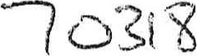



|  |  |
| --- | --- |
|  | L!CENSED %NUFACTURERZS DECLARATION |
| Note: Licensed Kit Manufacturer's must sign either Deckaration A for kits, DecEaration B for comp{ete wooden boats, or Dec'aration C for GRP boats. |
| A. Wooden Kit  { declare that this kit has been produced by our company in eccordance with the ISAF Kit Specifications and Pians and that [SAF P\aque Nurnber  was suppfied with the kit:  Company: |
|  | Signature:  Date: |
| B. Complete Boat (complete wooden boats, not kits)  t declare that this boat has been built by our compeny in accordance with ISAF Specifications and Plans for Wooden Mirrors and is in compfiance with the Internationef Mirror Class Rufes and that ISAF Plaque Number  has been affixed to the transom:  Company:  Signature:  Date |
| C. GRP Boat (complete GRP, not kits)  decEare that this boat hes been built by our company in accordance with ESAF Specifications for GRP Mirrors, in a mould approved by the ISAF and to the laminate schedule approved by the ISAF, and is in compliance with the International Mirror Class Rules and that fSAF Pfaque Numberhas been affixed to the transom:  Company:  Signature: |
| PROFESSIONAL OR AMATEUR BUELDER'S DECLARATION |
| To be completed by the Professional or Amateur Builder of a wooden kit supplied by a Licensed Kit Manufacturer on compfetion of the kit.  I declare that this boat has been completed using only parts and materials supplied with the kit (except where otherwise permitted by the Class Rufes) and in accordance with the Class Ru{es:  Builder  Signature: Date: |

|  |  |  |  |  |  |  |  |
| --- | --- | --- | --- | --- | --- | --- | --- |
|  | | | CHANGE OF OWNERSH{P | | | | |
| Note: Chenge of Ownership invalidates this Certificate. The new owner should sign the declaration be!ovv and send the Certificate to the National Authority for re-validation. | | | | |
|  | | | | |
| Second Owners Name:  Second Ownerls Address: | | | | |
|  | | | To be signed by the Second Owner:  i undertake to race this International Mirror oniy so long as I maintain it in conformity with the Class Ruies. t also undertake thet the weight correctors (if any) will not be altered or removed except when done in conjunction with an official reweighing and that only sails: spars etc.i which have been measured and found to be in accordance with the will be used.  Signature:                           Date:  This certificate is dated                    and its validity is confirmed by  for                                                          (Name of National Authority)  Signature:   Stamp of Authority | | | | |
| THRO OWNER'S DECLARATION | | | |
| Third Ownerts Name:  Third Ownerts Address:    To be signed by the Third Owner:  undertake to race this International Mirror only so long as maintain it in conformity with the Ciass Rules. I also undertake that the weight correctors (if any) will not be altered or removed except when done in conjunction with an official reweighing and that on!)' sails, spars etc., which have been measured and found to be in accordance with the rules, will be used.  Signature:  Date:  This certificate is dated  and its validity is confirmed by for             (Name of National Authority)  Signature:  Stamp of Authority | | | |
|  | | | | OWNERS DECLARATEON | | |
| To be signed by the First Owner:  undertake to race this International Mirror onfy so tong as i maintain it in conformity with the Cfass Rules. I aEso undertake that the weight correctors (if any) will not be altered or removed except when done in conjunction with an official reweighing and that only sails, spars etc., which have been measured and found to be tn accordance with the rules, will be used.  Name:  Address: | | |
|  | | | | Signature: | | |
| MEASUREMENT CERTF\CATE | | | |
| To be completed by National Authority:  Nationa( Letters: ...X. QW Sail Number:  Builder:  Ntumber of hull corrector weights: kg  Tote!  weight  of  (See Re-weighing Endorsement) This certificate is dated ...0 .3  by . .  (Block Capita:s) (Name of National Authority)  Signature:  Stamp of Authority | | | |

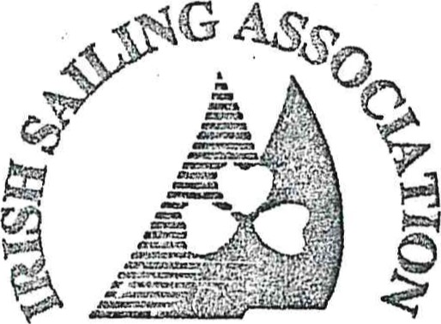

3 PARK ROAD, DUN LACGHAiR4

CO. DUBLIN,

280 FAX: 220

Effective: 20th August 2002

(C) ISAF Previous issue: 3rd March 1999

Oc3(8